**ARUNACHALA COLLEGE OF ENGINEERING FOR WOMEN**

**DEPARTMENT OF COMPUTER SCIENCE AND ENGINEERING**

**CUSTOMER CARE REGISTRY**

# DATA FLOW DIAGRAM & USER STORIES

|  |  |
| --- | --- |
| **DATE** | 1 November 2022 |
| **TEAM ID** | PNT2022TMID34000 |
| **PRIJECT NAME** | Customer Care Registry |

**PROJECT DESIGN PHASE-2**

**DATA FLOW DIAGRAM & USER STORIES**

**DATA FLOW DIAGRAM:**

A data flow diagram (DFD) is a graphical or visual representation using a standardized set of symbols and notations to describe a business's operations through data movement. They are often elements of a formal methodology such as Structured Systems Analysis and Design Method (SSADM).

**LEVELS IN DATA FLOW DIAGRAMS [DFD]:**

In Software engineering DFD(data flow diagram) can be drawn to represent the system of different levels of abstraction. Higher-level DFDs are partitioned into low levels-hacking more information and functional elements. Levels in DFD are numbered 0, 1, 2 or beyond. Here, we will see mainly 3 levels in the data flow diagram, which are:

• 0-level DFD • 1-level DFD • 2-level DFD

**0-LEVEL DFD:**

It is also known as a context diagram. It’s designed to be an abstraction view, showing the system as a single process with its relationship to external entities. It represents the entire system as a single bubble with input and output data indicated by incoming/outgoing arrows.

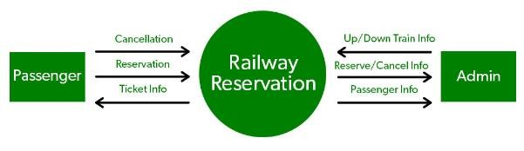

**1-LEVEL DFD:**

In 1-level DFD, the context diagram is decomposed into multiple bubbles/processes. In this level, we highlight the main functions of the system and breakdown the high-level process of 0-level DFD into subprocesses.

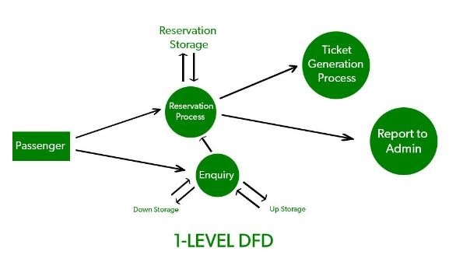

**2-LEVEL DFD:**

2-level DFD goes one step deeper into parts of 1-level DFD. It can be used to plan or record the specific/necessary detail about the system’s functioning.

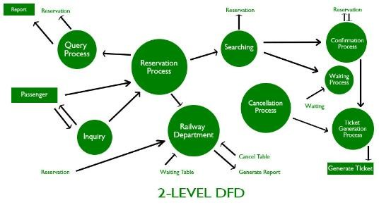

**DATA FLOW DIAGRAM [CUSTOMER CARE REGISTRY]:**

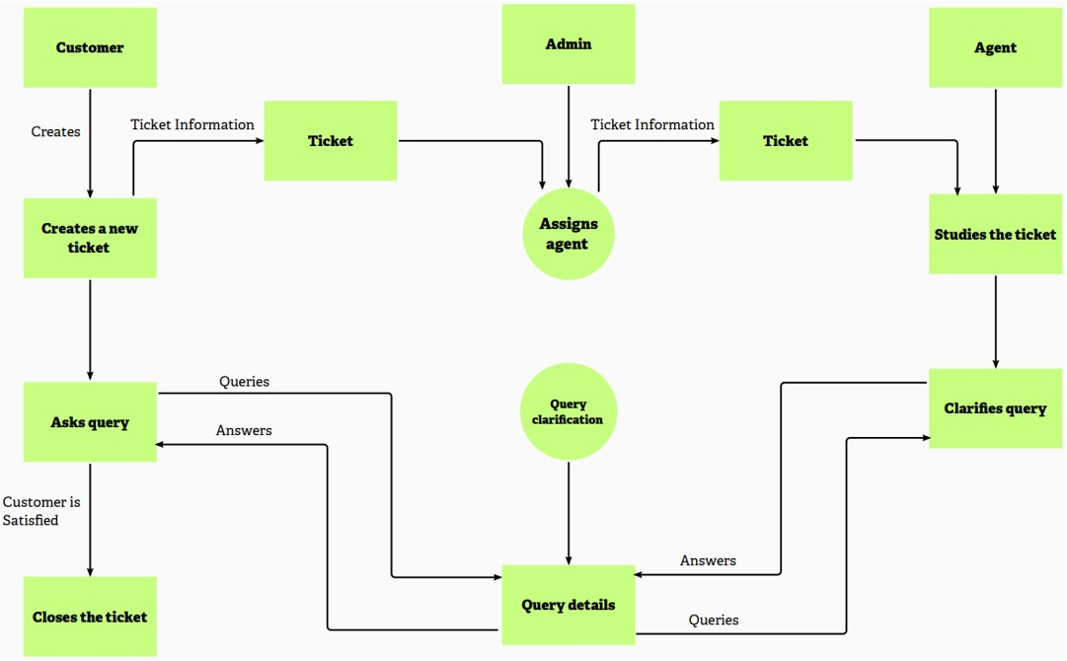

**USER STORIES:**

A user story is an informal, general explanation of a software feature written from the perspective of the end user or customer. The purpose of a user story is to articulate how a piece of work will deliver a particular value back to the customer.

**EXAMPLE:**

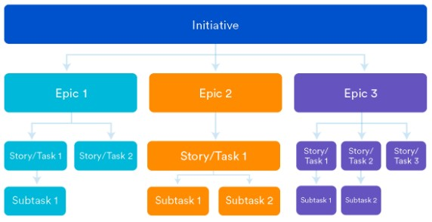

**USER STOREIS [CUSTOMER CARE REGISTRY]:**

|  |  |  |  |  |  |  |
| --- | --- | --- | --- | --- | --- | --- |
| **User Type** | **Functional**  **Requirement (Epic)** | **User**  **Story**  **Number** | **User Story / Task** | **Acceptance criteria** | **Priority** | **Release** |
| Customer (Web  user) | Registration | USN-1 | As a customer, I can register for the application by entering my email, password, and confirming my password. | I can access my account / dashboard | High | Sprint-1 |

|  |  |  |  |  |  |  |
| --- | --- | --- | --- | --- | --- | --- |
| **User Type** | **Functional**  **Requirement (Epic)** | **User**  **Story**  **Number** | **User Story / Task** | **Acceptance criteria** | **Priority** | **Release** |
|  | Login | USN-2 | As a customer, I can login to the application by entering correct email and password | I can access my account / dashboard | High | Sprint-1 |
|  | Dashboard | USN-3 | As a customer, I can see all the tickets raised by me and lot more | I get all the info needed in my dashboard | High | Sprint-1 |
|  | Ticket creation | USN-4 | As a customer, I can create a new ticket with the detailed description of my query | I can ask my query | High | Sprint-2 |
|  | Address Column | USN-5 | As a customer, I can have conversations with the assigned agent and get my queries clarified | My queries are clarified | High | Sprint-3 |
|  | Forgot password | USN-6 | As a customer, I can reset my password by this option in case I forgot my old password | I get access to my account again | Medium | Sprint-4 |
|  | Ticket details | USN-7 | As a customer, I can see the current status of my tickets | I get better understanding | Medium | Sprint-4 |
| Agent (Web  user) | Login | USN-1 | As an agent, I can login to the application by entering correct email and password | I can access my account / dashboard | High | Sprint-3 |

|  |  |  |  |  |  |  |
| --- | --- | --- | --- | --- | --- | --- |
| **User Type** | **Functional**  **Requirement (Epic)** | **User**  **Story**  **Number** | **User Story / Task** | **Acceptance criteria** | **Priority** | **Release** |
|  | Dashboard | USN-2 | As an agent, I can see all the tickets assigned to me by the admin | I can see the tickets to which I could answer | High | Sprint-3 |
|  | Address Column | USN-3 | As an agent, I get to have conversations with the customer and clear his/her queries | I can clarify the issue | High | Sprint-3 |
|  | Forgot password | USN-4 | As an agent, I can reset my password by this option in case I forgot my old password | I get access to my account again | Medium | Sprint-4 |
| Admin (Web  user) | Login | USN-1 | As an admin, I can login to the application by entering correct email and password | I can access my account / dashboard | High | Sprint-1 |
|  | Dashboard | USN-2 | As an admin, I can see all the tickets raised in the entire system and lot more | I can assign agents by seeing those tickets | High | Sprint-1 |
|  | Agent creation | USN-3 | As an admin, I can create an agent for clarifying the customer’s queries | I can create agents | High | Sprint-2 |
| **User Type** | **Functional**  **Requirement (Epic)** | **User**  **Story**  **Number** | **User Story / Task** | **Acceptance criteria** | **Priority** | **Release** |
|  | Assigning agent | USN-4 | As an admin, I can assign an agent for each ticket created by the customer | Enables agent to clarify the queries | High | Sprint-2 |
|  | Forgot password | USN-4 | As an admin, I can reset my password by this option in case I forgot my old password | I get access to my account again | Medium | Sprint-4 |